Practical No. 9
Aim : ALP to find Largest number from Array of numbers
Name : Danish Altaf Solkar Class : CO - B
Enrolment no. : 24111590805 Batch : 2
Code :-
assume cs:code
assume ds:data
data segment
arr DB 12H,07H,25H,18H,02H
largest DB ?
data ends
code segment
start:
MOV AX,Data
MOV DS,AX
MOV AX,0000H
LEA SI,arr
MOV CL,04H
MOV AL,[SI]
UP:INC SI
MOV BL,[SI]
CMP AL,BL
JNS DOWN
MOV AL,BL
DOWN:LOOP UP
MOV largest,AL
INT 03H
code ends
end start

OUTPUT :-
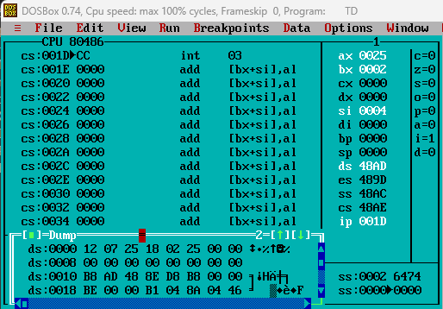

Process related  (15) | Product related  (10) | Total Marks  (25) | Signature

